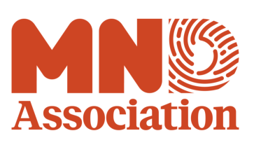

Application for open access publishing fees

Before completing this form, please read our ‘Grantee Guide to Open Access’ and the notes below.

Grantees of awards from the MND Association from 2011 onwards are mandated to make their peer reviewed papers directly arising from the grant available through open access. These research papers should be available within the UK PubMed Central (UKPMC) repository as soon as possible but within 6 months of publication of the paper.

The Association’s open access mandate applies to research that is wholly or substantially funded by the MND Association. Where research has been joint funded by another organisation, requests for open access fees will be considered on case-by-case basis.

This open access mandate excludes reviews, book chapters, editorials or conference proceedings. It also excludes publications arising from awards made prior to 2011.

Open access funding is not available for additional page and colour plate charges.

Please send a signed copy of the application form with evidence of acceptance from the journal to: research.grants@mndassociation.org

If approved, open access fees will be reimbursed upon receipt of an invoice from the grantee institution. A copy of the invoice from the publisher should be included as supporting information.

Application for open access publishing fees

Grantee details

Principal investigator
Institution
Grant title
Grant reference
Details of publication

Publication title
Authors
Journal name
Other funders supporting this work
Funding requested

Amount requested from MND Association
Amount available from other sources
I hereby confirm that the details given are accurate and that any money granted will be used to support open access publication charges only

Signature of principal investigator
Date
For MND Association use only:
Decision of application
Amount awarded
Date of decision
Date reimbursement invoice received
Date paid

Version 1.2

