(Costs are shown for information only. Materials are provided free to Branches and Groups)
MND awareness flyer A5  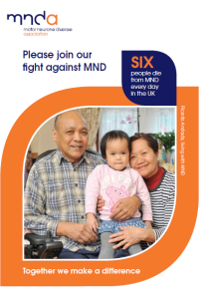  Information about MND and the Association | MND awareness poster  A4 & A3  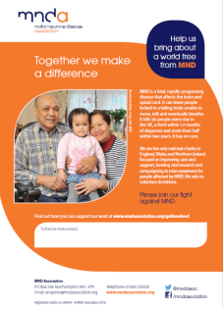  Readymade publicity | Posters (plain) A4 & A3  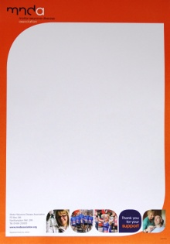  Add your own event details and message
Key messages flyer A5  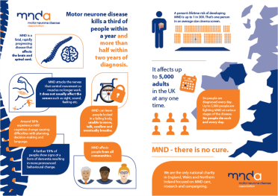  Key Facts about MND | Balloons  blue, orange, white  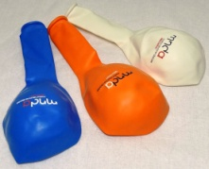  12” balloons, helium quality and biodegradable  (Cost 10p) | Flat pack  collecting box  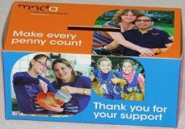  Ideal for spare change, either at home or a safe place at work  (Cost 50p)
The difference you could make A4  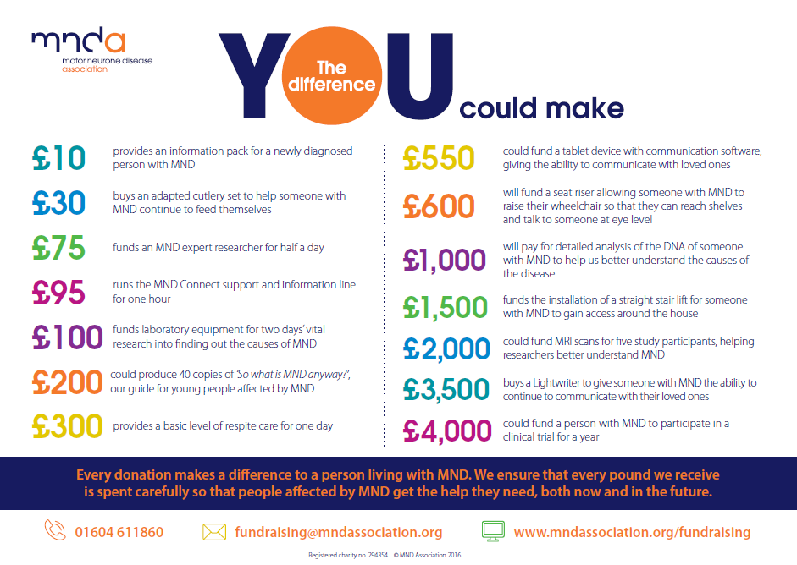  Breakdown of how your money can help | Lapel stickers  (24 per sheet)  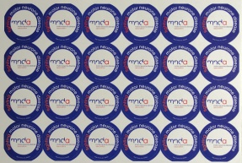  Perfect to use at collections  (Cost 25p) | Lightweight banner  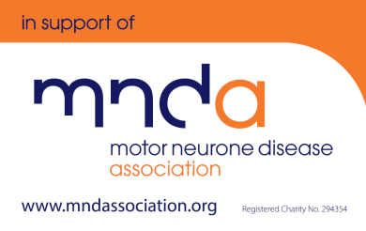  Approx. size 50cm x 75cm  (Cost 30p)
T Shirts (unisex)  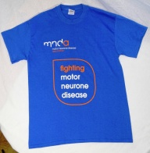  Raise awareness at your event  (Cost £5) | Car stickers  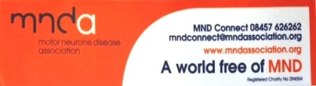  Place proudly in your  vehicle or window  (Cost 15p) | Sponsor form A4  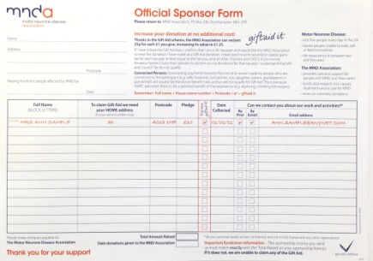  34 sponsors per form

Collecting tin  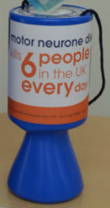  Each tin needs a wrap and a seal  (Tin Cost £2) | Collecting bucket  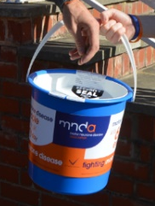  Each bucket needs a wrap and 2 seals  (Bucket Cost £4) | Static collection tin  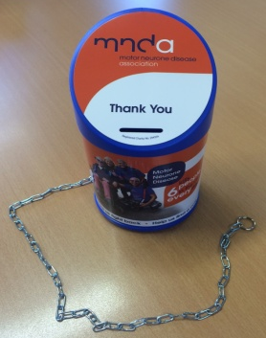  For long term use in shops & businesses  (Cost £3)
 | Stationery  - A4 headed paper  - Compliment slips | Wraps and seals  - Tin wraps  - Tin seals  - Bucket wraps  - Bucket seals

Please order your materials using the Your Materials order form below.
Available to buy online

Wristbands  orange & blue  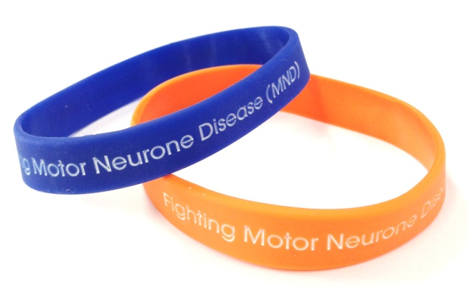  Cost £2 | Festival wristbands  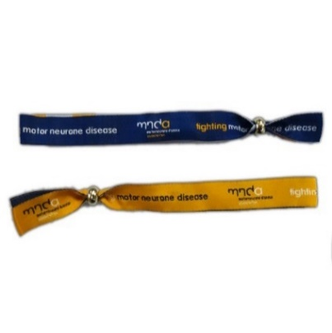  Cost £2 | Thumbs up pin badges  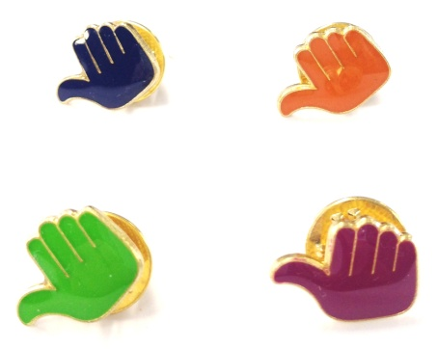  Cost 40p
Bunting  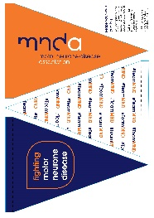  Cost £2.50  (2 metres long - 6 flags) | MND Association badges (enamelled)  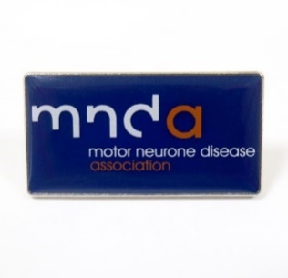 | Running vest (unisex)  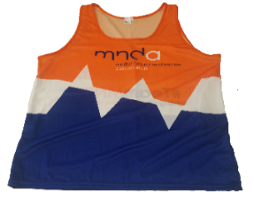  Cost £10.00  Please use for running events only

You can order these items by emailing sales@mndassociation.org

Your materials order form
We have a selection of materials available, which are useful for telling everyone what you are doing, decorating your stall/venue or branding you group/branch event.

We are pleased to offer these items free of charge to groups and branches, however we have indicated the costs so you can be mindful only to order the quantities you need and will use.
Please complete the Your Materials Order Form below and return to: The Volunteering Team, MND Association, Francis Crick House, 6 Summerhouse Road, Northampton NN3 6BJ or email to: volunteering@mndassociation.org

Delivery Information: To ensure items are delivered on time, please place your order at least 10 working days prior to your event date.

Name: | Telephone number:
Delivery Address | Date Required By:
Delivery Address | Event Date:
Delivery Address | Preferred  Delivery Address:  If different to the address stated. Please note, larger delivery items will need to be signed for.
Membership Number:

Description | Please state quantity/size required
T shirts (unisex) | Select size (approx):- |  | S (36”):
T shirts (unisex) | M (39”): |  | L (42”):
T shirts (unisex) | XL (45”): |  | XXL (48”):
Sponsor forms
MND awareness flyer A5
Poster (Awareness) A4
Posters (Awareness) A3
Poster (Plain) A4
Poster (Plain) A3
Key messages flyer A5
Balloons -blue, white and orange
Flat pack collecting box
The difference you could make A4
Lapel stickers (24 per sheet)
Lightweight banner
Collecting tins
Collecting buckets
Static collection tins
Car stickers
Compliment slips
A4 headed paper

If you have any questions, please call 01604 611681 during office hours.
Many thanks for your support, it is truly appreciated.

